

11 Physics

Nuclear Physics

ATOMS, ISOTOPES AND RADIOISOTOPES

Atoms of elements are composed of protons and neutrons (referred to as nucleons) in a nucleus (nuclei are also referred to as nuclides) with electrons in different energy level orbits around the nucleus. The nucleus contains nearly all of the mass of the atom, but accounts for less than a million millionth (10^{–12}) of its volume.

The atomic number of an element is equal to the number of protons in each of its atoms. It is this that determines which element an atom represents. The atomic number is also equal to the number of electrons in orbit around the atom.

Atomic number (Z) = number of protons = number of electrons in a neutral atom.

The mass number of an element is the sum of the numbers of protons and neutrons in the nucleus.

Mass number (A) = number of protons + number of neutrons in the nucleus of an atom.

Atoms are represented by the symbol 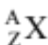.

e.g. 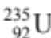 represents Uranium - 235.

The atomic mass of an element (often incorrectly referred to as its mass number ) is the average mass of its atoms. Atomic mass takes into account that not all atoms of an element have the same mass due to the presence of isotopes of that element.

Atomic mass = average mass of the nuclides of an element (isotopes considered).

Isotopes are atoms of elements that have different numbers of neutrons in their nuclei. Representing the same element, these atoms must have identical numbers of protons in those nuclei. Isotopes have the same chemical properties (they react and bond with other atoms in precisely the same way) but different physical properties.
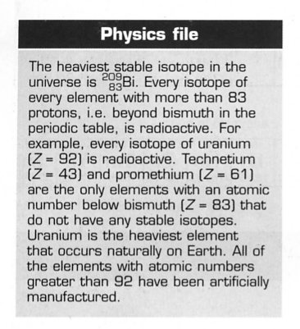
Radioisotopes are naturally occurring isotopes that are unstable. An unstable nucleus may spontaneously lose energy by emitting a particle and so change into a different element or isotope. Unstable atoms are radioactive and an individual radioactive isotope is known as a radioisotope.

e.g. Carbon has two stable isotopes (C-12 and C-13) and one
isotope in nature that is not stable (C-14).

The nucleus of a radioactive carbon-14 atom may
spontaneously decay, emitting high-energy particles that
can be dangerous.

Extra Information

Protons, neutrons and electrons are not the smallest sub-atomic particles.

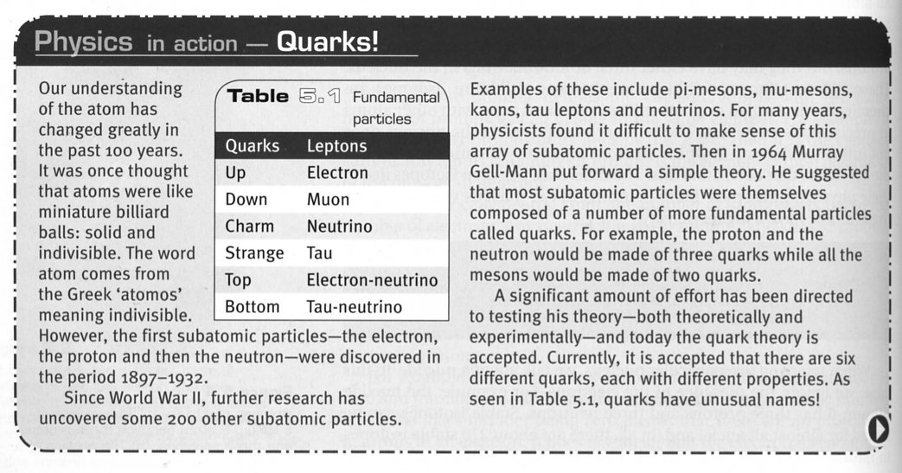
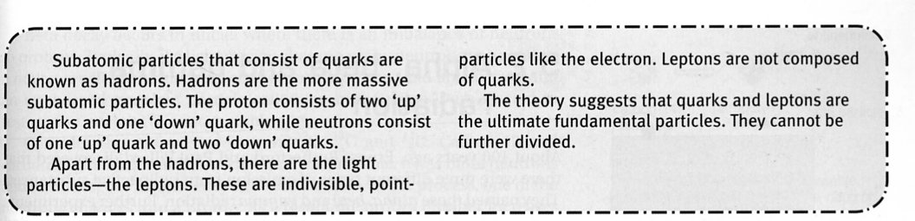

TYPES OF RADIATION

Why Radioactive Nuclei are Unstable

Radioactivity is the name given to the radiations emitted by certain elements that are unstable. It was determined by experiment that radioactivity was due to the disintegration or decay of the nucleus by the emission of a particle or particles, and / or energy in the form of light.

The nucleus, particularly that of a large atom, is unstable and contains too much energy. In order to become more stable, it emits either a particle (that carries energy away as E_{k}) or light in the form of gamma rays (very high energy light).

Inside the nucleus, there are two completely different forces acting.

• An electric force of repulsion between the protons. On its own, this would blow the
nucleus apart, so clearly a second force must act to bind the nucleus together.

• The nuclear force, a powerful force of attraction between nucleons, which acts only
over a very short range.

In a stable nucleus, there is a delicate balance between the repulsive electric force and the attractive strong force.

There appears to be a connection to the presence of neutrons. The nuclear force is found to weaken when too few or too many neutrons are present.

i.e. The following diagram shows the relationship between proton and neutron number for
the elements.
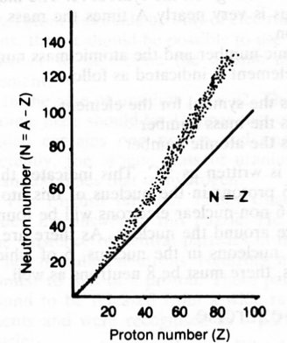

For Z < 40, number of protons and neutrons are about the same. These are very stable.

For larger nuclei, the neutron number becomes bigger than the proton number. This
reduces the repelling force between the protons and makes the nucleus stable.

For Z > 83, the nuclear force is not strong enough to overcome the repulsive
electrostatic force between the protons. All of these nuclei are radioactive.
History of Radiation

The accidental discovery of radioactivity by Henri Becquerel in 1896 began a quest for understanding that has had far-reaching effects on life on Earth. The existence of radioactive particles caused scientists to wonder where they came from. The realisation that the nucleus of an atom was not a solid, unbreakable entity, but consisted of other particles that could be released in extreme conditions was emerging.

• 1896 Henri Becquerel discovered radioactivity, accidentally observing that a
uranium salt emitted rays that darkened a photographic plate.

• 1898 Rutherford showed that Becquerel's radiation consisted of alpha particles
and beta particles.

• 1900 Paul Villard discovered gamma rays , the third component of Becquerel 's
radiation.

• 1902 Rutherford and Frederick Soddy proposed that the emission of radioactivity
was the result of radioactive transformations. These occur when a nucleus
splits into two smaller nuclei. It emits radioactivity.

Types of Radiation

Ernest Rutherford and Paul Villard discovered that there were three different types of emission from radioactive substances. They named these alpha (α), beta (β) and gamma (γ) radiation.

Experiments showed that the alpha and beta emissions were actually particles expelled from the nucleus. Gamma radiation was found to be high-energy electromagnetic radiation, also emanating from the nucleus.

These radiations were identified by passing them through a set of parallel plates with a large potential difference (voltage) across them.

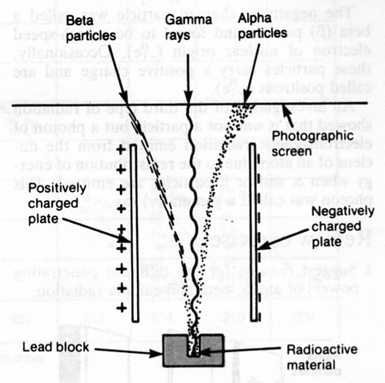

This experiment showed the following about the various radiations.

Alpha (α) particle • Positively charged (attracted to negative plate).
• Relatively large mass (takes longer to "bend" in its path).

Beta (β) particle • Negatively charged.
• Relatively light particle (its path "bends" quickly).

Gamma (γ) Ray • No charge (not deflected).
• No mass.
• Pure energy in the form of electromagnetic radiation (light).

Properties Of Radiation

 | α | β | γ
Symbol | 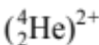 | 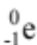 | 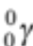
Charge | + 2 | - 1 | 0
Mass | Approx. 4u | 9.11 x 10⁻³¹ kg | 0
Speed | ~ 0.1 c | ~ 0.9 c | c
Penetration | Stopped by a few cm of air.  (Big and slow means lots of collisions.) | Stopped by a few metres of air, 1-2 mm of Al. | Mostly absorbed by a few cm of Pb - never completely absorbed.
Ionising Effect | Very high.  (Large size makes it easy to remove electrons from atoms.) | Not great due to its small size. | Very small since it is pure energy and not a particle.

• 1u = 1.66 x 10⁻²⁷ kg • c = speed of light = 3.00 x 10⁸ ms⁻¹

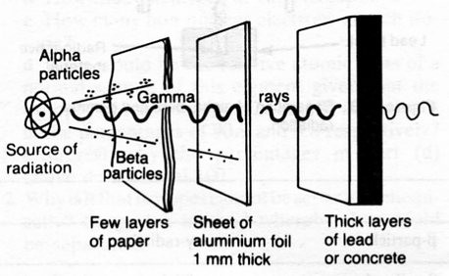
TRANSMUTATION OF RADIOACTIVE ELEMENTS

Transmutation: the change of one element into another by the emission of radiation.

Radioactive substances disintegrate spontaneously, emitting α or β particles (usually accompanied by γ rays). After emitting an α or β particle, the nucleus is still unstable and the emission of a γ ray removes the excess energy and the nucleus returns to a stable state.

The process of transmutation is represented by nuclear equations. The rules for these equations are as follows.

• The algebraic sum of the atomic numbers of the reacting species equal the algebraic
sum of the product species. This conserves charge.

• The algebraic sum of the mass numbers of the reacting species equal the algebraic
sum of the product species.

Alpha Decay

An alpha particle is identical to a helium nucleus with no electrons. Hence its charge is +2. The symbol can be written as or 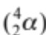.

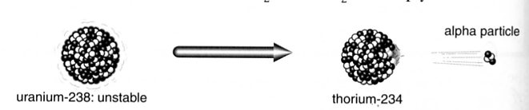

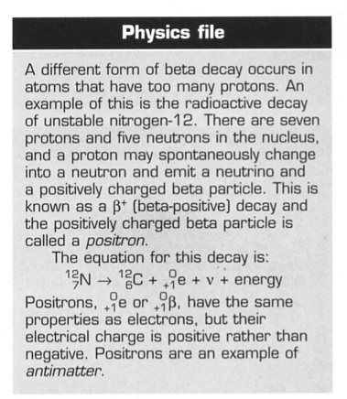
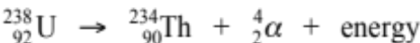

The energy released is carried as E_{k} by the α particle.

Beta Decay

Beta particles are electrons, but they are electrons that have originated from the nucleus of a radioactive atom, not from the electron cloud. The symbol can be written as or 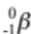. The charge is -1 and the zero indicates its mass is far less than either a proton or neutron.

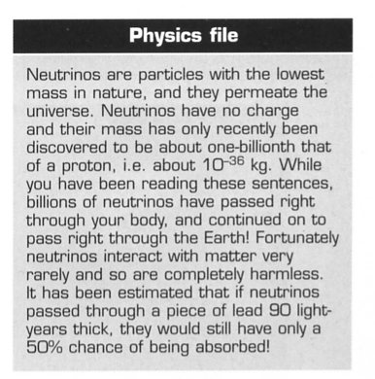
Beta decay occurs in nuclei where there is an imbalance of neutrons to protons. Typically, if a light nucleus has too many neutrons to be stable, a neutron will spontaneously change into a proton, and an electron and an uncharged massless particle (called an antineutrino ν) are ejected to restore the nucleus to a more stable state.

i.e. 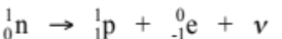

C-14 is unstable with too many neutrons and undergoes a beta decay.

Gamma Decay

Generally, after a radioisotope has emitted an alpha or beta particle, the daughter nucleus holds an excess of energy. The protons and neutrons in the daughter nucleus then rearrange slightly and off-load this excess energy by releasing gamma radiation (high-frequency electromagnetic radiation).
Gamma rays—like all light—have no mass and are uncharged and so their symbol is .

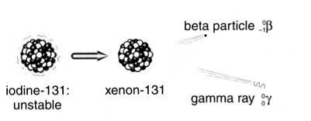

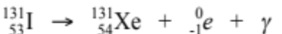

Artificial Transmutation

Most of the radioisotopes that are used in industrial and medical applications are synthesised by artificial transmutation. There are now over 2000 such artificial radioisotopes.

e.g. One of the ways that artificial radioisotopes are manufactured is by neutron absorption.
(In Australia, this is done at the Lucas Heights reactor near Sydney.)

The neutron is absorbed into the nucleus and this creates an unstable isotope of the
sample element, which usually becomes a beta emitter.

Cobalt-60 (widely used for cancer treatment) is manufactured from Cobalt-59.

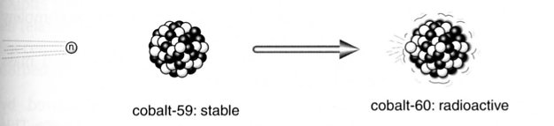

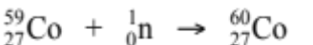
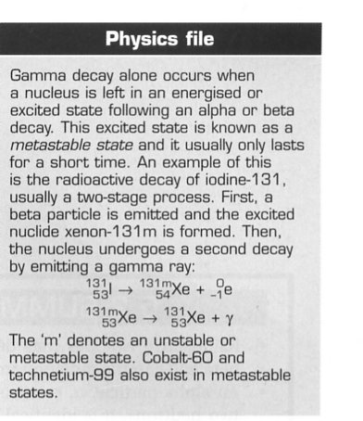
DETECTING RADIATION

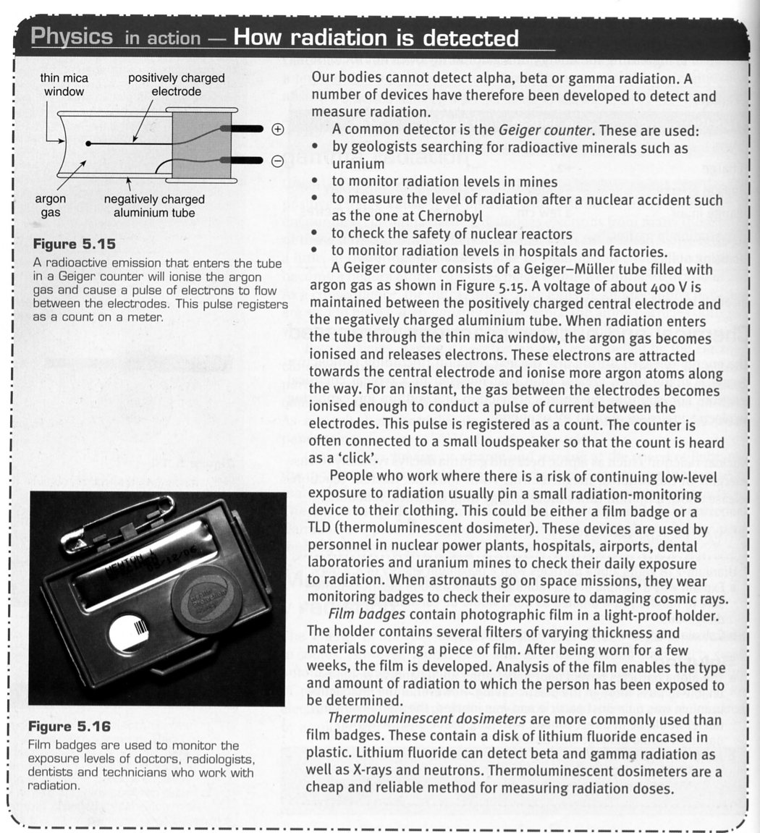

HALF-LIFE OF RADIOISOTOPES

Different radioactive elements decay at different rates. The rate of decay is directly proportional to the number of undecayed radioactive atoms remaining.

Consider the decay of a sample of Polonium-218, assuming 100 million atoms exist initially.

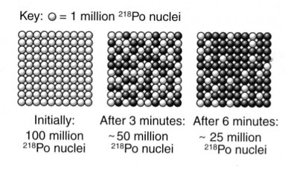

Every 3 minutes, half of the radioactive nuclei decay.

i.e. The amount left decreases by half every 3 minutes.
Hence the half-life is 3 minutes.

Half-Life: the time taken for half of the radioactive atoms in a sample to decay.

This relationship can be seen in the following diagram.
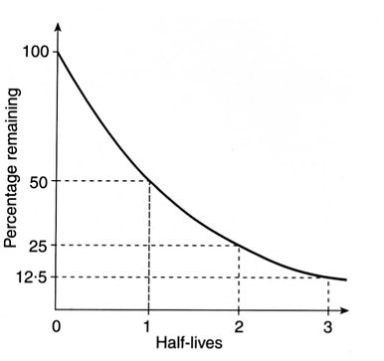
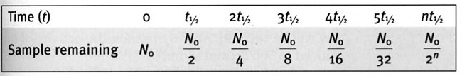

From the graph it can be seen that the decay reduces exponentially in the following way.

• After two half-life periods, only 1/4 of the radioactive atoms remain.
• After three half-life periods, only 1/8 of the radioactive atoms remain.
• After four half-life periods, only y 1/16 of the radioactive atoms remains.

Thus the fraction of radioactive atoms remaining after a given time can be calculated by:

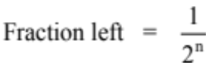

where n = the number of half-life periods of time.
This fraction can be used to determine the number of undecayed atoms left in a sample, the mass of the radioactive element left or the radiation count given off by the remaining undecayed atoms.

The decay equation can then be written as:

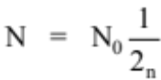

where N = number of undecayed atoms, mass of remaining radioactive
atoms or" the radiation count given off by the undecayed
atoms.
N₀ = the original number of atoms, original mass, or the original
count rate.

Example

A radioactive element X has a half-life of 2.00 x 10³ years. If a 50.0 g sample gives a count rate of 1.00 x 10³ counts per minute now, what would be:

(a) the count rate, and
(b) the mass of element left after 1.00 x10⁴ years?

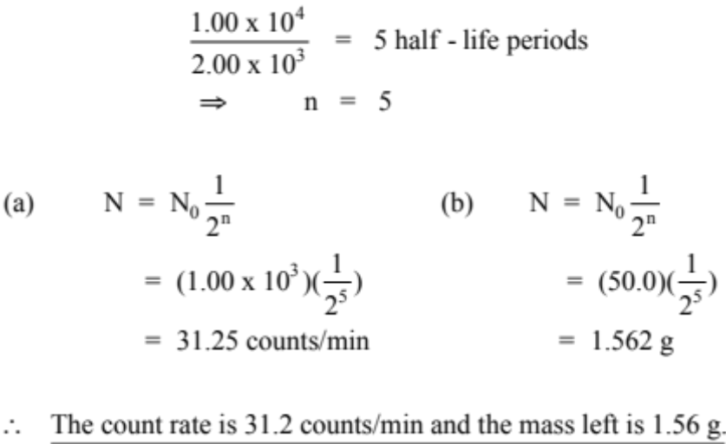

Notes

1. The fact that only 1.56 g of element X is left in the example above, it does not mean that
this is the mass of the sample. X would have transmuted into another element that would also
be present, and hence would add its own mass to that of the remaining X.

i.e. The 50.0 g of X would become 1.56 g of X and about 44.0 g of other elements,
allowing for some mass being converted into energy during the transmutation
process.

2. This relationship can be expressed mathematically as:

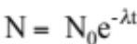

where N = number of undecayed atoms at time t.
N_{o} = number of atoms present i n the original Sample
λ = radioactive constant for the particular element (the fraction of
nuclei that decay per unit time)

This expression shows two things about radioactive decay.

• The number of radioactive atoms decreases with time.
• The level of radiation will approach zero, but never reach it.

Examples
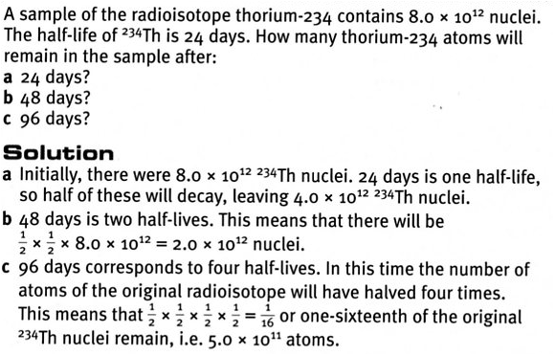
1.

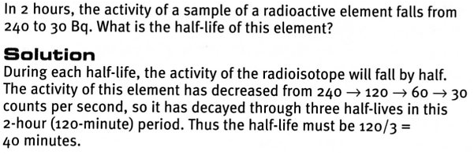
2.

APPLICATIONS OF RADIOISOTOPES

Radioactive isotopes are widely used in the areas of industry, medicine and research. The usefulness of isotopes is related to their properties and to the effects of their radiation.

• Radiation can alter the structure of materials.

A single alpha or beta particle can cause the ionisation of several atoms as it passes through a
substance. This ionising effect makes possible the operation of such devices as smoke
detectors and the destruction of cancerous cells using radiation therapy.

• Radiation reveals information about the materials it interacts with.

The penetrating power of the different forms of radiation varies with the type of material.
The amount of radiation passing through or reflected by a material can indicate its density or
thickness. This can be used to discriminate between different materials or detect flaws within
materials.

• Radioactive materials can be easily traced as they move through a system.

Even very small quantities of radioactive material can be detected fairly readily. This allows
for their use in tracer techniques. Hence radioisotopes can be used to trace the path of
chemicals within the body monitor biological processes or detect the occurrence of a leak
from a gas pipeline.

Medical Uses Of Radioisotopes

Some of the most valuable applications of the use of radioisotopes occur in the field of medicine.
Radioisotopes are powerful tools for analysis, diagnosis and treatment. Two important applications are radiation therapy and tracer techniques.

• Gamma radiation therapy involves the use of a high activity cobalt-60 source for the
treatment of inoperable tumours.

The source provides a thin beam of radiation, which is directed at the tumour. The source is
continually rotated around the patient so that surrounding tissue will receive a relatively small
exposure. The tumour, however, being the centre of this rotation, will receive a high dose of
radiation and its cells will die.

• Tracer techniques. A radioactive isotope may be given to a patient by injection or
swallowing and then its progress monitored as it moves through the body.

Different substances are taken up by different organs of the body. Hence specific tracers are
chosen to look at particular organs. (See the table below.)

Radioisotopes chosen as tracers usually have a fairly short half-life. Since only very small
amounts of tracer are introduced into the body the short half-life ensures a high activity and
easy detection. It also means that the isotope is not active in the body for too long.

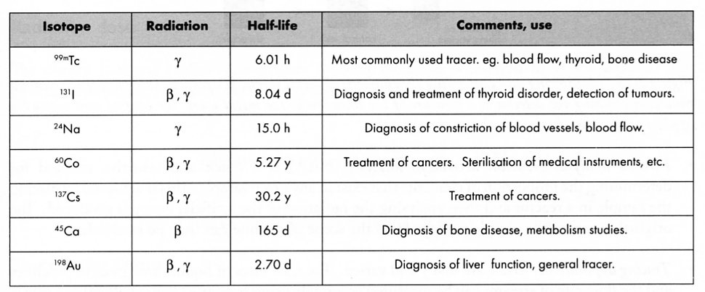

The radioactive isotope technetium-99m is the most commonly used tracer. Its advantages include a short half-life (6.0 h), low production cost and chemical versatility. It can be introduced in various forms so as to be a tracer for checking such things as blood flow, thyroid function, bone disease, liver and heart function and detection of tumours.

Other Uses Of Radioactive Isotopes

The use of radioisotopes in the areas of industry, agriculture and research are both interesting and varied. A brief description of some of these uses is listed below.

• Industrial radiography. Isotopes such as iridium-192 can be used to check flaws in steel
welding. This is much like an X-ray. The γ radiation will discriminate between materials of
different density; the steel being denser than the weld. This technique of non-destructive
quality control can also be used to inspect castings, ceramics and critical machinery such as
aircraft engines.

• Gauging. The thickness of sheet materials, such as sheet plastic or sheet metal, can be
controlled without them being physically measured. The γ radiation from a source such as
cobalt-60 has its intensity reduced as the thickness of the material it passes through increases.
The reading by a radiation detector on the other side of the material can be used to monitor
the correct thickness required during production.

In the packaging industry, the same technique can be used to ensure containers are correctly
filled.

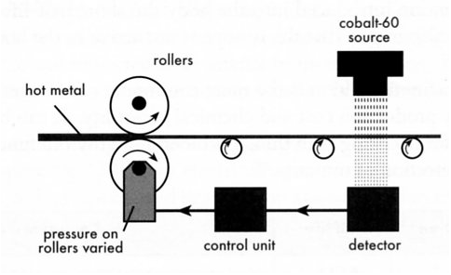.
• Forensic analysis. Neutron activation analysis (NAA) is a quick and sensitive method for
determining the proportion of elements that exist in any given sample. This is achieved by
placing the sample in a reactor and then analysing the radiation of the artificial isotopes
produced. The original source of the sample, perhaps from the scene of a crime, can then be
established.

• Tracing applications. These are many and varied. The flow rates of liquids and gases in
pipelines and the flow rate of streams can be measured accurately using sodium-24 or
cobalt-60 as a tracer. Importantly, leaks and blockages that occur in pipelines can also be
investigated.

e.g. Gold-198 has been used in a study to track Sydney's sewage after its disposal out to sea.
The flow of hot materials inside a blast furnace can also be analysed for efficiency using
this same isotope.
In agriculture, tracers are important in the study of such things as biological processes,
soil erosion, use of fertilisers and insect biology.

• Smoke detectors. This important safety device is able to operate due to the ionising effect of
americium-241, which emits a particles. An electronic alarm is prevented from sounding
while a current is able to flow due to the presence of ionised air particles (see diagram).
Smoke particles interfere with this current flow and hence trigger the alarm.

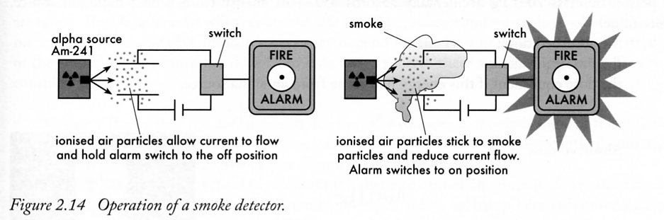

• Food irradiation. Cobalt-60 can be used to irradiate packaged food and help increase its
shelf life. The γ radiation passes through the food, destroying bacteria and micro-organisms
that causes food spoilage or food poisoning. Many countries do this, but not in Australia.
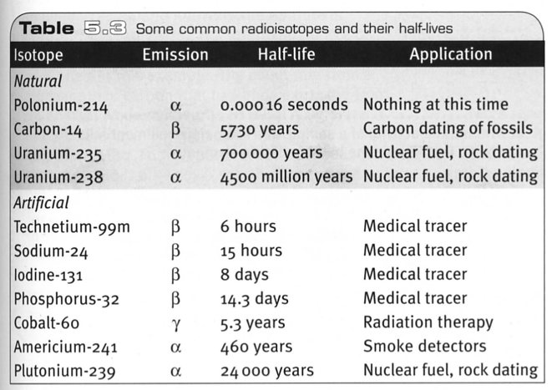

Carbon-14 Dating

C-14 has a half-life of 5730 years and can be used to determine the age of formerly living plants and animals. It is useful up to around 50,000 year old materials.

(See the half-life diagram on the next page.)

It is used in dating things such as bone, cloth, wood and plant fibres that were created in the relatively recent past by human activities.

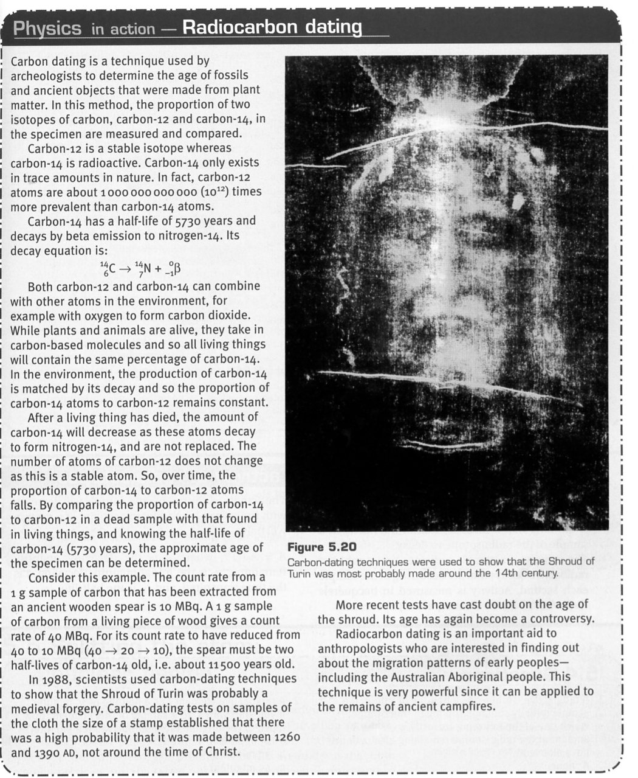
Rock Dating

Radioisotopes with very long half-lives are useful to determine the age of rocks, which have ages up to 4.5 billion years. (See half-life diagram below.)

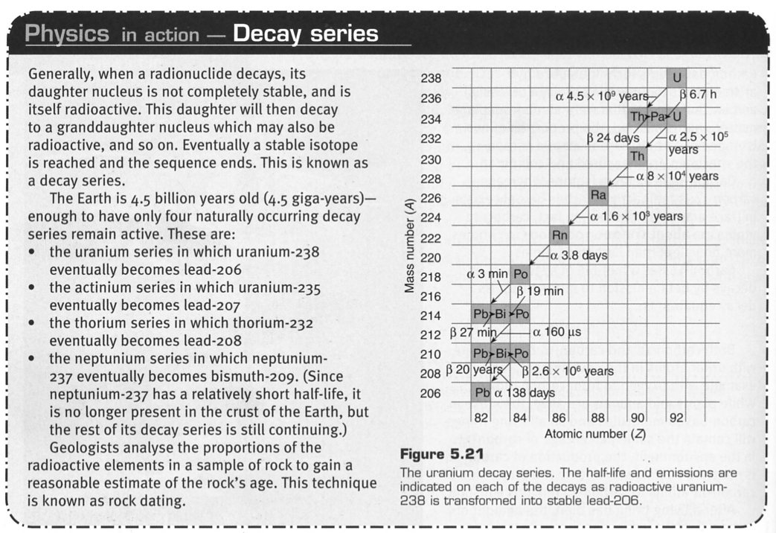

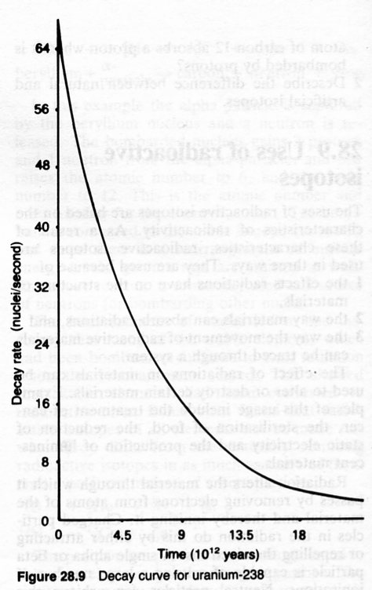

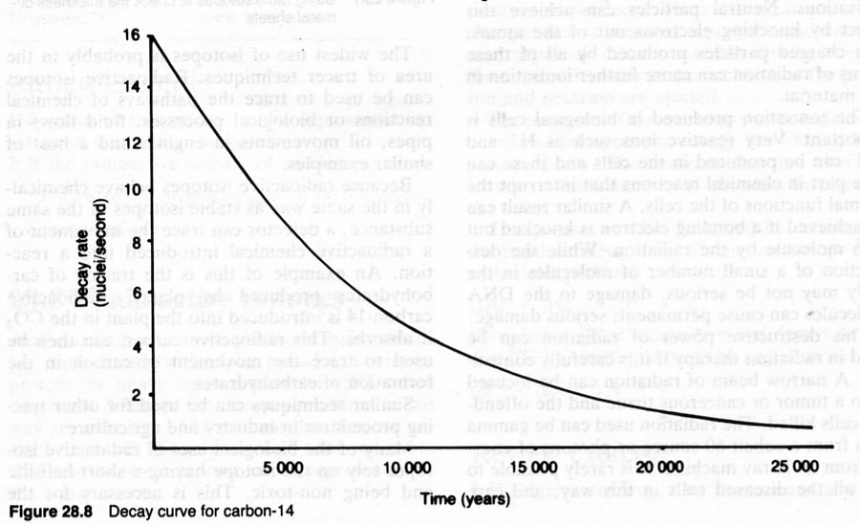

BIOLOGICAL EFFECTS OF RADIATION

Radiation damage to the living body cells depends on two factors.

• The energy the cells absorb from the radiation.
• The time over which the cells absorb the radiation energy.

When ionising radiation interacts with living cells it transfers its energy to the individual atoms that make up the cell. This may cause damage to the cell by ionisation and the formation of extremely chemically reactive atoms or groups of atoms known as free radicals.
.
Where atoms or molecules are ionised, this can cause a change in the cell processes and cell chemistry.

e.g. If DNA molecules are ionised, the effect may be the prevention of cell division , the
premature death of the cell or a permanent genetic modification.

Radiation Dose

The energy that our bodies receive from ionising radiation is referred to as the absorbed dose. Specifically, the absorbed dose is the energy absorbed per kilogram of tissue.

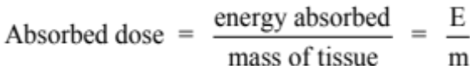

The SI unit for absorbed dose is the gray (Gy).

1.00 Gy = 1.00 Jkg ⁻¹

The Quality Factor

Absorbed dose is useful when comparing the effects of different amounts of the same radiation. However, it is not useful when the effects of different types of radiation are considered.

The effects of different types of radiation on living cells vary. Alpha particles are far more ionising than gamma rays because of their large size. Hence equal doses of these two types of radiation can have quite different biological effects.

The quality factor for a particular radiation indicates the cell damage it causes in comparison to an equal dose of γ rays. The dose equivalent (in Sieverts) is a measurement that incorporates the quality factor.

This means that 1.00 Sievert of any type of radiation will have the same biological effect.

Dose equivalent is given by the following.

1.00 sievert (Sv) = 1.00 Jkg⁻¹
Quality Factors
Radiation Type | Approximate Quality Factor
gamma rays | 1
beta particles | 1
slow neutrons | 3
fast neutrons | 10
alpha particles | 20

Example

A person of mass 70.0 kg accidentally absorbs 45.0 J of energy from a beta radiation source. Determine:

(a) the absorbed dose.
(b) the dose equivalent.
(c) the dose equivalent if this energy had come from an alpha source.

(a)
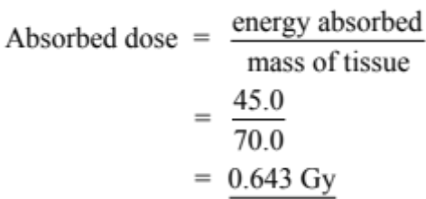

(b)
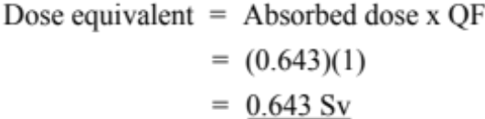

(c)
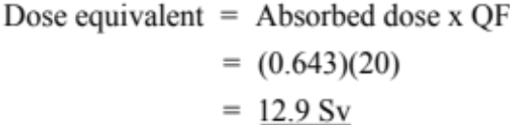

Effects Of Ionising Radiation On People

The effect of radiation on our bodies is due to the damage or changes that occur at the cellular level. The magnitude of this effect is proportional to the radiation dose equivalent received. The symptoms from a large radiation dose to the body become evident within a few days or weeks.
These include nausea and vomiting and a general unwellness (radiation sickness).

The likely effects of large radiation doses are:

• 1,000 mSv - nausea, vomiting and diarrhoea (radiation sickness) will occur within days.
Fatal cancers may form later in life.

• 10,000 mSv - death likely to result within 2 weeks due to damage to white blood cells
and the gastrointestine.

• 100,000 mSv - death within hours or days due to severe damage to the central nervous
system.

Some parts of the body are more sensitive to ionising radiation than others. The most sensitive are bone marrow, the reproductive organs, the eye and the digestive and circulatory systems.

e.g. Doses of 2000-3000 mSv to the testes or ovaries will cause permanent sterility while
similar doses to the eye will result in cataracts.

Lower doses of radiation may produce effects that only become apparent after several months or even years. These include a reduced life expectancy, the development of leukaemia or tumours and cataracts on the eye lens. Genetic damage, if it occurs, may not be apparent for several generations.

Dose Equivalent (Sv) | Body Damage
0.25 | Reduction in lymphocyte (white blood cell) count.
1 | Possible nausea, vomiting.
4 | Nausea, diarrhoea, drop in blood cell count. About 50% of exposed group die within weeks from failure of blood-forming organs.
5 | Loss of hair, 50% die.
6 | Damage to stomach and intestine walls with loss of fluids. Immediate radiation sickness, bloody diarrhoea, extreme thirst, purpura, death within 3 weeks.
10 | Severe damage to central nervous system. Death within days.

Lethal Dose

LD is the symbol for lethal dose, meaning a dose that results in death.

LD-50 represents a mean lethal dose that will kill 50% of the exposed people.

This has been extended to LD-50/25, which represents the dose that will kill 50% of exposed people in 25 days.
Radiation safety

The fact that we cannot see radiation makes it essential that appropriate protective safety measures are taken. Regulations exist that cover the safe handling, storage and waste disposal of radioactive materials.

The preventative measures necessary depend on the type of radiation and the strength of the source.

To minimise the dose from radioactive sources there are three important factors to consider. These are:

• Distance - the further you are from a source the safer you are. Not only is some of the
radiation absorbed by the air or materials between you and the source but more
importantly the intensity will drop off rapidly with distance. (See the diagram below.)

• Shielding - is particularly important if distance cannot be minimised. It can be chosen
to absorb particular radiation.

e.g. Perspex sheets will stop beta radiation; lead and concrete will absorb
gamma rays, while boron and cadmium are good absorbers of neutrons.

• Time - the longer you are exposed to a source the greater the absorbed dose. Good
planning can minimise this.

e.g. Radioisotopes used in medicine are chosen so that they have a short
biological half-life. This means that they are present in the body for
a shorter time.

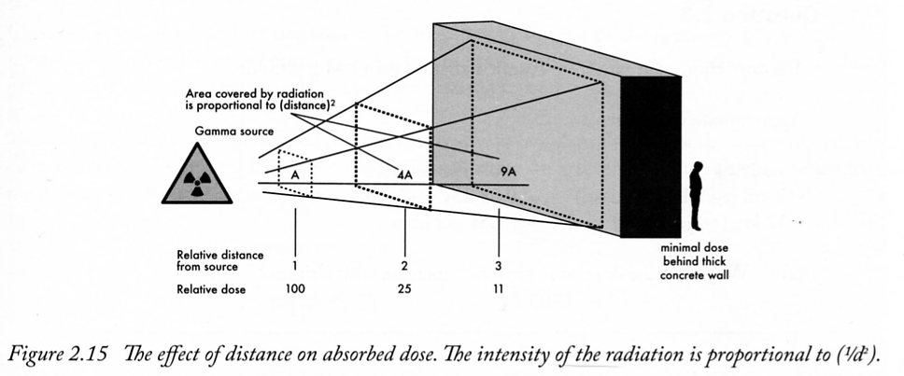

NUCLEAR BINDING ENERGY

When a nucleus is bombarded with a suitable particle, it may cause a nuclear reaction if its E_{k} is sufficiently large to overcome the energy that is binding the nuclear particles together. If a reaction occurs, the nucleus is rearranged into a more stable configuration with a release of some energy.

Binding Energy: the energy that must be supplied by a bombarding particle to separate
the nucleus into its component parts.

The standard unit of atomic mass is the atomic mass unit (u).

1.00 u = ¹/₁₂ x mass of one C-12 atom
= 1.66 x 10⁻²⁷ kg

The energy equivalent of this is given by Einstein's Equation.

E = mc²
= (1.66 x 10⁻²⁷) (3.00 x 10⁸)²
1.00 eV = 1.60 x 10⁻¹⁹ J

∴ Divide by 1.60 x 10⁻¹⁹
= 1.494 x 10⁻¹⁰ J
= 9.314 x 10⁸ eV
= 931.4 MeV

∴ 1.00 u = 931.4 MeV

Note The binding energy is usually measured in MeV.

When individual particles come together to form a nucleus, energy is released. This release of energy is always accompanied by a loss of mass. This loss of mass is often referred to as the
mass defect.

This means that the measured mass of a nucleus is always less than the sum of the individual masses of its nucleons.

Example 1

Determine the binding energy per nucleon for the Helium atom.

A Heliurn atom is made up of 2 protons., 2 neutrons and 2 electrons. Hence its mass should
be:

2 x m_{p} = 2(1.00728) = 2.01456 u
2 x rn_{n} = 2(1.00867) = 2.01734 u
2 x m_{e} = 2(0.00055) = 0.001113 u
4.03300 u

The mass of a Helium atom is 4.00389 u.

∴ Mass defect = 4.03300 u - 4.00389 u
= 0.02911 u
= (0.02911)(931.4)
= 27.11 MeV
Helium has 4 nucleons.

∴ Binding energy per nucleon = 27.11
4
= 6.778 MeV

∴ The binding energy per nucleon = 6.80 MeV

Note The binding energy for the nucleus is 27.11 MeV. This is the energy a bombarding
particle needs to split the nucleus into its constituent parts.

Example 2

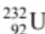 decays to 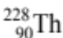 by emitting an alpha particle.

(a) What energy is released when this disintegration takes place?
(b) In what form is this energy released?

Masses = 232.0372 u
= 228.0207 u
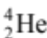 = 4.0039 u

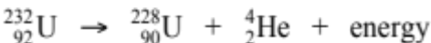

⇒ 232.0372 u → 228.0287 u + 4.0039 u
⇒ 232.0372 u > 232.0326 u

Mass difference = mass of reactants - mass of products
= 232.0372 u - 232.0326 u
= 0.0046 u
= (0.0046)(931.4)
= 4.284 MeV

∴ Hence the energy released is 4.3 MeV, mainly as the E_{k} of the alpha particle.

Note It is possible to do "mass defect" problems with masses in kilograms. This requires
converting Joules to electron volts.

BINDING ENERGY AND MASS NUMBER

The binding energy of heavier nuclei is larger than that for light nuclei due to the greater number of nucleons that are separated.

The binding energy per nucleon increases as the mass number approaches 60. Atoms with
a mass near this number are most stable because they have the highest binding energy per
nucleon.

After 60, the binding energy per nucleon decreases, indicating a decrease in nucleus stability as more nucleons are packed in.

Generally, nuclei heavier than 60 will lose energy by disintegrating (in a process called fission), and those below 60 will lose energy by combining with other nuclei (in a process called fusion). In both cases, the nuclei will move towards the most stable mass number of 60.

Note Some lighter nuclei such as He-4, C-12 and O-16 have a nuclear stability that does not
fit the general case.

The following graph shows the general trend in binding energy per nucleon.

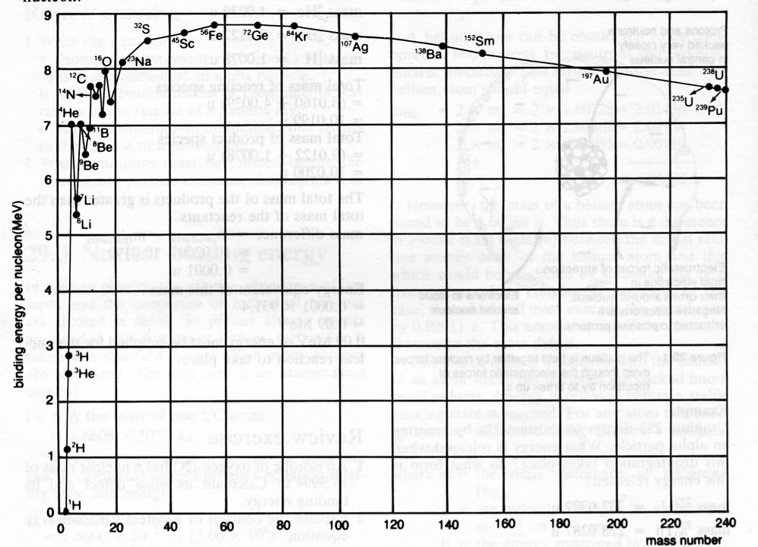

NUCLEAR FISSION

Nuclear fission is the splitting of the nucleus of an atom into two smaller nuclei. In this process large amounts of energy are released as well as gamma radiation and some neutrons . Fission can be spontaneous or induced by the absorption of neutrons.

A typical fission reaction for uranium-235 is:

Krypton-91 and barium-142 are known as the fission products or fission fragments. Three neutrons are freed from the uranium nucleus when it splits.
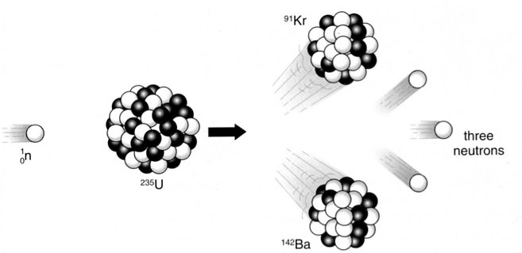

The uranium can break up into any of several different combinations of nuclides. Typically, however, the heavier particle has a mass number around 130 to 150 and the lighter fragment around 90 to 100.

Over 40 different pairs of fission fragments of uranium-235 have been found, and most of these are radioactive beta emitters. It is these radioactive fission fragments that comprise the bulk of the high level waste produced by nuclear reactors.

Typically around 200 MeV is released during a fission reaction.

Example

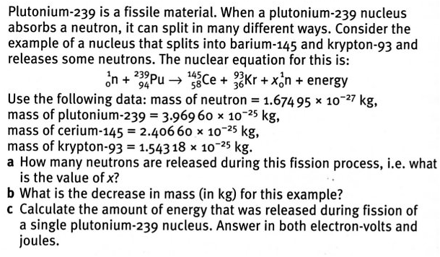
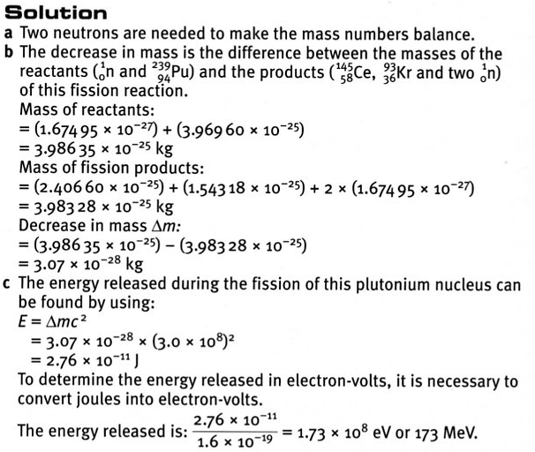

Chain Reactions

When a uranium-235 nucleus undergoes a fission reaction , some neutrons, usually two or three, are always released . If at least one of these neutrons is able to hit another uranium-235 nucleus , a
self- sustaining chain reaction results.

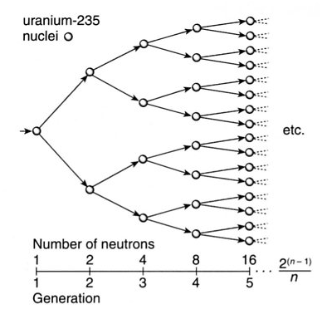

In the diagram above, two neutrons are released during the fission reaction. The number of nuclei undergoing fission doubles each generation and within a small fraction of a second an enormous number of nuclei have undergone fission.

Only a minuscule amount of energy (of the order of 10^{–13} J) is released by each fission reaction, but in this uncontrolled chain reaction there are so many reactions occurring in such a short time that
an explosion results.

In 1.00 kg of uranium-235, so many reactions occur that about 8 x 10¹³ J of energy is released in just over one-millionth of a second.

Fortunately, such a chain reaction does not easily occur due to a variety of factors.

• Neutrons may simply escape from the material without hitting any nuclei.
Remember, nuclei are an extremely small part of an atom.

• Neutrons may be absorbed by uranium -238 nuclei, which rarely undergo fission.
Only 0.7% of naturally occurring uranium is the fissile uranium-235.

• Only the very slow neutrons, called thermal neutrons , are likely to cause uranium-
235 to split. Fast neutrons emitted from a fission reaction are more easily captured by
uranium-238.

Critical Mass

Critical mass refers to the mass of fissile material required to sustain an uncontrolled chain reaction such as that which occurs in an atom bomb. If too little matter is present, most of the neutrons produced in a fission reaction escape from the material without interaction .

Critical mass depends on:

• the % of uranium-235 or plutonium-239 in a sample. (Uranium-238 is not fissile.)

The fuel used in nuclear fission weapons is enriched to a high degree of purity
(over 90 % U-235)) so that a chain reaction can be sustained. Nuclear reactors require
3 % U-235.

• the geometry (shape) of the mass.

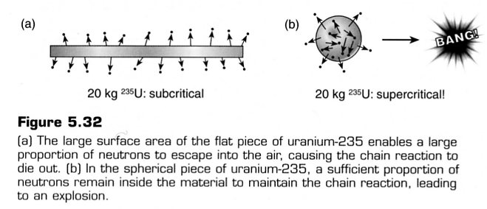

Atomic Bomb
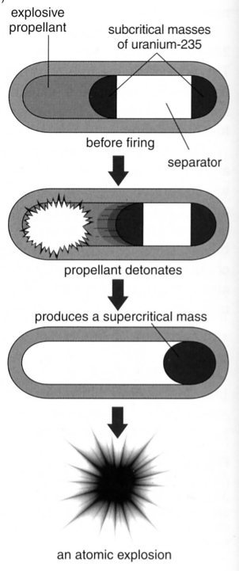
When an atom bomb is detonated, two separate masses of fissile material, each less than critical mass, are forced together by a chemical explosive.

The two combined masses are then greater than critical mass and an explosion results.

The nuclear bomb that was dropped on Hiroshima contained two
hemispherical sub-critical pieces of 95% pure uranium-235. This bomb,
known as Little Boy, was dropped by a B-29 bomber called the Enola Gay
on 6 August 1945. When it reached an altitude of 580 m, an explosive charge fired one piece into the other, creating one supercritical mass of uranium- 235, which exploded within one-millionth of a second after this.

Thermal Nuclear Reactors

Nuclear reactors are able to produce large quantities of heat as a result of a controlled chain reaction. Enriched uranium-235 is used in thermal reactors while plutonium-239 is used in fast-breeder reactors. The heat produced in a reactor passes through a heat exchanger and eventually drives a turbine to produce electricity .

Reactor design can vary widely with the choice of fuel and moderator being of particular importance. In order that a controlled chain reaction can be sustained in a reactor an average of one neutron from each fission must cause another fission.

Hence enriched uranium is preferred since natural uranium only contains 0.7% of this fissile material. Also, since slow neutrons are more likely to cause the fission of uranium-235 a moderator is used to slow down the energetic neutrons produced during fission reactions .

The design features of thermal nuclear reactors include:

• Nuclear fuel Modem reactors use enriched uranium (≈ 2 - 3 % uranium-235) in the form
of uranium dioxide.

• Moderator Although fast neutrons can cause fission in uranium-238 (the more abundant
isotope), the probability of fission of uranium-235 by slow neutrons is
much higher. Hence a moderator is used to deliberately slow down the
neutrons to normal thermal energy. Hence the term thermal reactors.
Graphite, water, heavy water and beryllium are commonly used as
moderator materials.

• Control rods The rate of the fission reaction is controlled by lowering or raising the
boron- steel control rods. Neutrons are absorbed by the boron and inhibit
the chain reaction.
• Coolant This can be water, a gas (CO₂), or liquid metal (Na). The coolant removes
heat from the reactor core and transfers it to the outside of the reactor for
the generation of electricity.

• Radiation shield This consists of very thick reinforced concrete with steel, graphite and lead
layers. Its purpose is to protect workers and the nearby environment.

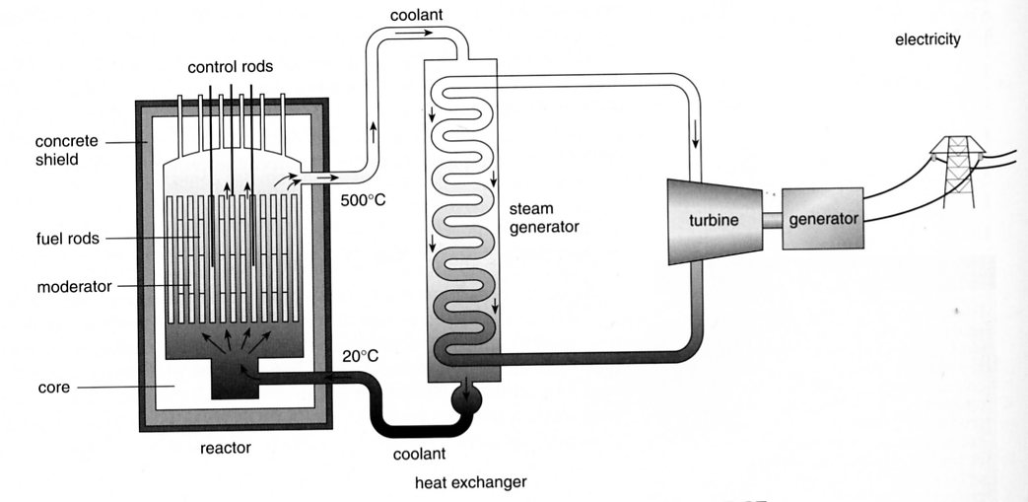

Fast-Breeder Reactors

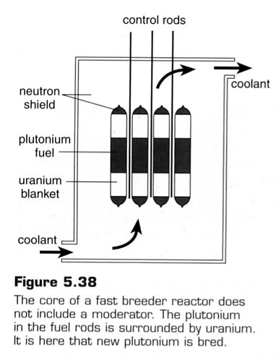
The Earth’s known supply of the relatively scarce uranium-235 may run out within a few decades if its use is increased. In this event, many current nuclear reactors will become obsolete. A different type of reactor, known as a fast breeder reactor, may therefore come into greater prominence in the future. Fast breeder reactors make use of the most abundant uranium isotope,
uranium-238.

These reactors use mixed plutonium uranium fuel, which is initially produced as a by-product of thermal reactors. Fast moving neutrons cause the fission of the plutonium-239 and hence the release of energy. These reactors also convert the normally wasted uranium-238 to plutonium-239, hence the name breeder reactors.

The plutonium-239 is then extracted for use in the next generation of fuel rods. However, it can be extracted for use in atomic weapons and this makes their use highly controversial.

Fast breeder reactors are very expensive to build and they suffer from many technological difficulties. At present, there are only a handful of fast breeder reactors in operation in France, the United States, Britain, Russia and Japan.

(See p. 194 of Heinemann Physics for more information.)
NUCLEAR FUSION

An important type of nuclear reaction that occurs in nature is fusion. Fusion occurs in the Sun and the stars. It is how heavier elements are formed from light nuclei such as hydrogen and helium.

Fusion involves the joining of two small nuclei to form a larger one. When this occurs, energy is released and the mass of the products is less than the mass of the reactants.

This release of energy is possible since atoms such as helium have a much greater binding energy per nucleon than smaller atoms such as hydrogen and deuterium. This indicates that the helium nucleus is particularly stable.

Fusion reactions are difficult to sustain. Strong electrostatic forces prevent nuclei from coming close enough together for the strong nuclear forces to be effective. Temperatures in the order of 100 million K (10⁸ K) are necessary to maintain such reactions. This forms a plasma of electrons and positive ions. If the ions gain enough energy, they will unite to form heavier nuclei, and energy will be released.

Nuclear fusion occurs on the sun and during the explosion of a hydrogen bomb.

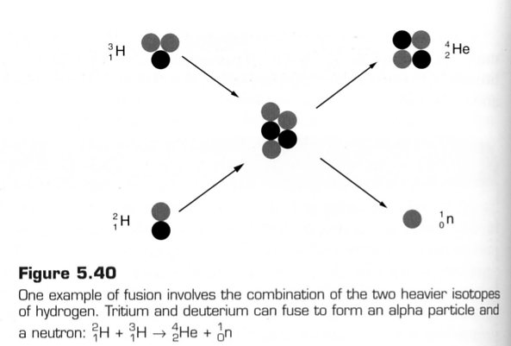

Some typical fusion reactions involving the isotopes of hydrogen (hydrogen 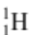, deuterium 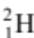 and
tritium 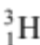) are as follows.

Fusion Reactors

Several fusion reactions form the helium nucleus, but the one between deuterium and tritium occurs the most easily. This particular reaction holds the greatest promise for achieving a controlled fusion process in the future. The major attractions of fusion power produced from such a process are as follows.

• A ready supply of fuel that is almost limitless. Deuterium is available from seawater
while tritium can be produced from beryllium.

• Waste products that are non-radioactive. This is a huge advantage over present fission
reactors since it removes the problem of storing radioactive wastes safely for long
periods.

• Safer reactors. Fusion reactors dealing with low-density plasma would not be subject
to melt down. Reactors could be sited more readily within communities.

The major difficulty in harnessing fusion power is the very high temperatures needed for the reaction. At these high temperatures plasma cannot be easily confined. Research is being undertaken using strong magnetic fields to trap the plasma (very hot ionised gas) that exists during a fusion reaction . At present the most encouraging design is a doughnut shaped device known as a tokomak. It uses large currents to create a toroidal magnetic field that can hold the plasma away from the container walls. Scientists are hopeful that this will lead to a practical fusion reactor in the future.

(See p. 196 Heinemann Physics for more information.)

The Hydrogen Bomb (also known as a thermonuclear bomb)

The temperature produced by a simple fission bomb (atom bomb) can be used to initiate a thermonuclear reaction. A hydrogen bomb essentially consists of a small atomic bomb surrounded by large amounts of lithium and deuterium. The initial fission reaction raises the temperature sufficiently for fusion to take place between deuterium and tritium. The tritium is formed when neutrons interact with lithium. Vast amounts of energy are released.

